Voice Coach — Análisis de voz
Idioma: English · Duración: 33s · Palabras: 53 · Ritmo: 95 ppm · Positividad: 66% · Muletillas: 0 · Generado: 7/11/2026, 11:25:14 PM

Métricas


Arco de sentimiento
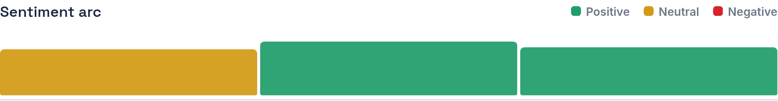

Transcripción
Through food executives who work throughout the USA understand that negotiation is that they require further more patience and work. Currently, many advantages it is for those who can speak Portuguese and decide to pursue a career in international business. It's a truthful fact that so hard work you can achieve your goals.
Color del texto — Verde: positivo · Amarillo: neutral · Rojo: negativo

